TÍTULO / TITLE / ARIAL 14
AUTORES / AUTHOR NAMES / ARIAL 10 ^{a*}
ªAFFILIATION / ARIAL 8
e-mail
Copyright 2023, ALAGO.
This paper was selected for presentation by an ALAGO Scientific Committee following review of information contained in an abstract submitted by the author(s).

Introduction (ARIAL 11 BOLD)
TEXT /ARIAL 10

Diamondoids are known to be present in petroleum fluids since 1930´s, but its usefulness as geochemical indicators was only developed in the last 20 years. They differ from saturated hydrocarbons because of the structural rigidity observed from the diamondoid-like three dimensional cages, which enhance resistance to thermal and microbial degradation and, then, the occurrence of diamondoids in mature and overmature oils. In addition, ultra-deep reservoirs are an important frontier for petroleum exploration, demanding both scientific and technological investments to achieve long term profit. To this oil accumulations, however, traditional biomarker parameter from saturated hydrocarbons are much less useful, therefore diamondoid assessment is needed understand such petroleum systems.

Experimental (ARIAL 11 BOLD)
TEXT / ARIAL 10

Two Brazilian crude oil samples were selected because of their differences in thermal maturity (Sample A and Sample 207). diamondoids when applying standard fractionation procedures for saturated biomarker analysis. Approximately 100 mg of each crude oil were deposited in the top of a dry silica gel column and then eluted with 5 mL of n-hexane.

Results and Discussion (ARIAL 11 BOLD)
TEXT / ARIAL 10

Since one of the targets of this study was the volatile adamantanes, evaporations after liquid chromatography as needed for n-paraffin removal were avoided. By this way, one could assess saturated biomarker, diamondoids and the extended diamondoids of a sample in only one chromatographic run.
Sample A. Sample 207 showed two tiny peaks from triamantane and methyltriamantane, but with signal-to-noise ratio lower than 10 (~ 4) – below the initial requirements.
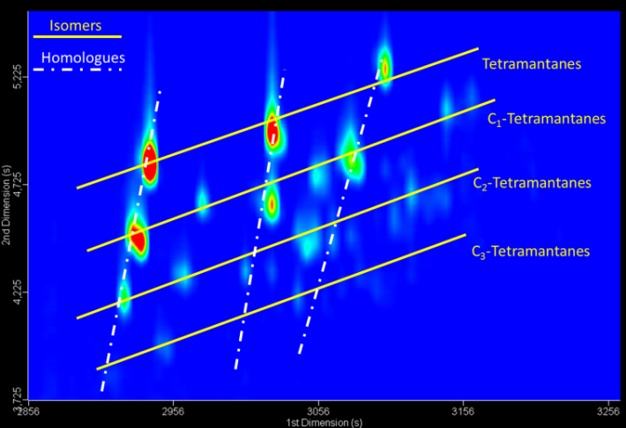

Figure 1.(ARIAL 9)
Chromatographic surface of tetramantanes.

It is important to note that all experimental set up were planned to allow analysis of both extended diamondoids and biomarkers simultaneously, achieved by exploring the high peak capacity and improved resolution that are inherent to GCxGC-TOFMS systems. Although not shown, main biomarker identification was possible. Figure 3 shows few maturity parameters from saturated biomarkers.

Conclusions (ARIAL 11 BOLD)
TEXT / ARIAL 10

We have explored GCxGC-TOFMS features aiming an expansive diamondoid analysis in two example crudes. GCxGC-TOFMS has satisfactory awareness, specially adequate if the objective is to study extended diamondoids, what includes non-target compounds. Not withstanding, knowledge should increase further if one correlates the position of the alkylsubstitution to the retention time of new discovered isomers, e.g. new diamondoid indexes can be proposed from extended diamondoids.
Figure 2. (ARIAL 9)

Saturated biomarker parameters from ……

Acknowledgements (ARIAL 11 BOLD)
TEXT /ARIAL 10

The authors thank CNPq (Brazilian research council) for fellowships; ANP (Brazilian Petroleum Agency), Petrobras S/A and PGQu – UFRJ for financial support.

References (ARIAL 11 BOLD)
(ARIAL 9) ORGANIC GEOCHEMISTRY STYLE
Azevedo, D. A.; Tamanqueira, J. B.; Dias, J. C. M.; Carmo, A. P. B.; Landau, L.; Gonçalves, F. T. T., 2008. Multivariate statistical analysis of diamondoid and biomarker data from Brazilian basin oil samples. Fuel87, 2122-2130.

